Experiment #
Company Name: Roving Blue, Inc.
Principal Investigator/Lead: Marianna “Yana” DeMyer
Objective:
Our objective changed from a straight line experiment regarding our units output (to prove the ability to autonomously re-supply a platoon of 42 soldiers with potable water in 24 hours) to a demonstration of the unit’s operation, and to showcase two possible new capabilities. The reason for the change is that we have already proven the output capability at JIFX 15-3 at Camp Roberts, CA. (A technical experimentation program put on by the NPS – Naval Post Graduate School). At that event we were challenged by a USASOC Science & Technology NCO to provide a solution to keeping water pure AFTER purification of a Roving Blue unit.
Our first objective was to answer the challenge: we brought along and demonstrated a prototype mobile “Tank Sentry” (working name) that could keep water pure on an on-going basis, also using ozone. The small portable unit can be dropped into a tank to keep water pure.
Our second objective was to demonstrate an enhanced capability, which is the addition of a new water filter. The filter’s pore size is 5 nanometers; small enough to capture disease agents as small as a virus.
Our third objective was also to provide samples of both output water (produced on site in front of the volunteers), and store-bought bottled water, and ask if anyone could tell the difference in taste quality between the two waters.
Quantitative/Qualitative Results:
With regards to the Tank Sentry, and the Roving Blue Unit with the new filter, we were able to demonstrate the prototype unit 15 times, not counting the repeat visits. (23 total) Numerous Special Operations active duty servicemen from the Army, Navy, Air Force, and Marines had hands-on experience with the unit. Science and Technology evaluators and other Government entities were also in force and asked many questions about filtration, power, electrical connections, and water output. Several other technology developers approached and discussed synergies.
There were only two demonstrations in which the observers did not actually drink our output water. Everyone else that took the time to watch the full demonstration, drank the water. They also compared the quality of taste to a case of “Ice Mountain” bottled water from Wal-Mart. They ALL said the output water of the Roving Blue unit was “AS GOOD” or “BETTER” than the bottled water.
This is of great importance to us because many soldiers complained about bad-tasting water at FBO’s and fouling of “Camelback” type water bladders, which our system addresses with Activated Carbon filtration (which removes tastes and odors and in-organic substances like chlorine) and with Ozone, which also oxidizes any organic tastes and odors, not only in the water, but in the receptacle that the water is going into.
We were also able to prove that our unit floats, if dropped into water.

Observations and Comments:
The SOCOM TE 15-3 was a very valuable experience, on multiple levels.
First and foremost the ability to directly demonstrate our technology to potential end-users and our TRL level is nothing but priceless. The feedback was just what we needed to know; that we are going down the correct path to production. Only very slight modifications would be necessary to satisfy most users. The core advice we left with: Don’t change a thing until you are talking with the folks who are buying it from you.
We were able to discuss and verify that our Tank Sentry technology should be modified to accept the same ubiquitous power input parameters as our existing unit (10-30VDC and 110-220AC) and to have a programmable timer so that it would work effectively for different volumes of water on a regular on-going basis.
The filter manufacturer represents that the new 5 nanometer filter has already achieved P248 standards. Essentially, this means there is already pure water in our system, prior to the ozone generator. This frees up the ozone module to do more work in downstream sanitizing roles, rather than acting strictly as a water sanitizing agent.
We learned that it is the downstream sanitizing capability of our unit (other being “smallest and lightest”) is probably our best feature. The relative low cost of the unit (expected to be under $4,000), was also an attribute. The fact that a case of our filters could equate to 100,000+ bottles of water in the field was also of interest to those involved with potable water re-supply logistics.
Lastly, the video and photo-opportunities were fantastic, due to the unique nature of the venue.

*Note*: We will producing a video devoted to our experience at SOCOM 15-3 Technical Experiments.
We did include some footage in this video which we are presenting at the Global Water Summit
The week of 6.22.2015 in Milwaukee, WI. You may see it here.

Photos:
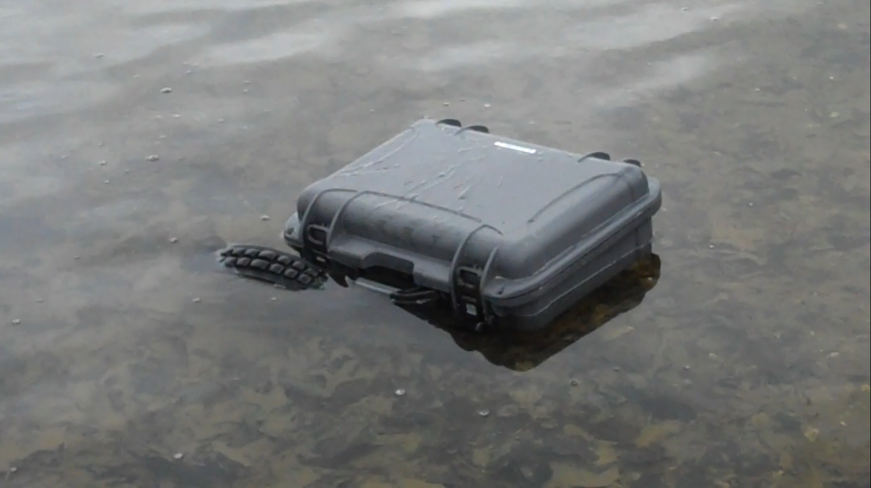
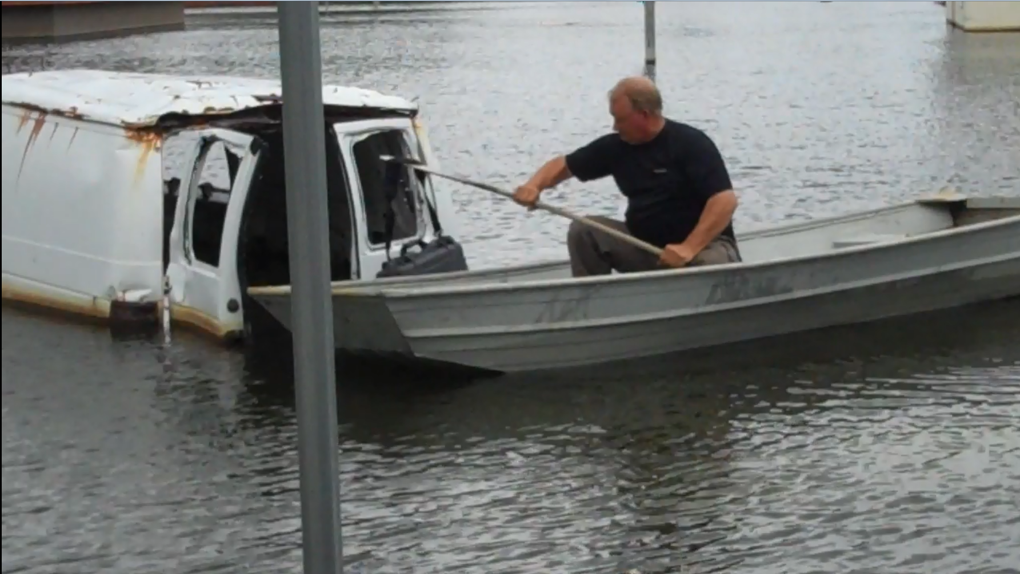
Roving Blue CEO Jim Gilmet retrieving a Roving Blue unit thrown into the water at the “flooded village” location.
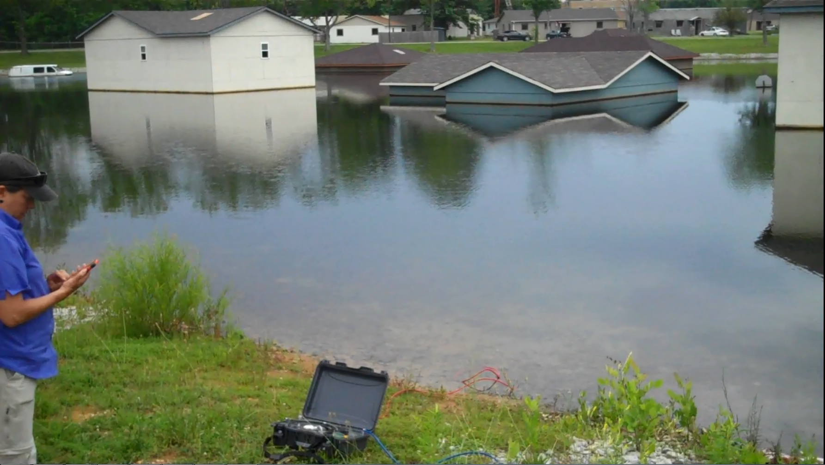
Roving Blue, Inc. CEO Marianna “Yana” DeMyer, operating the unit at the “Flooded Village”
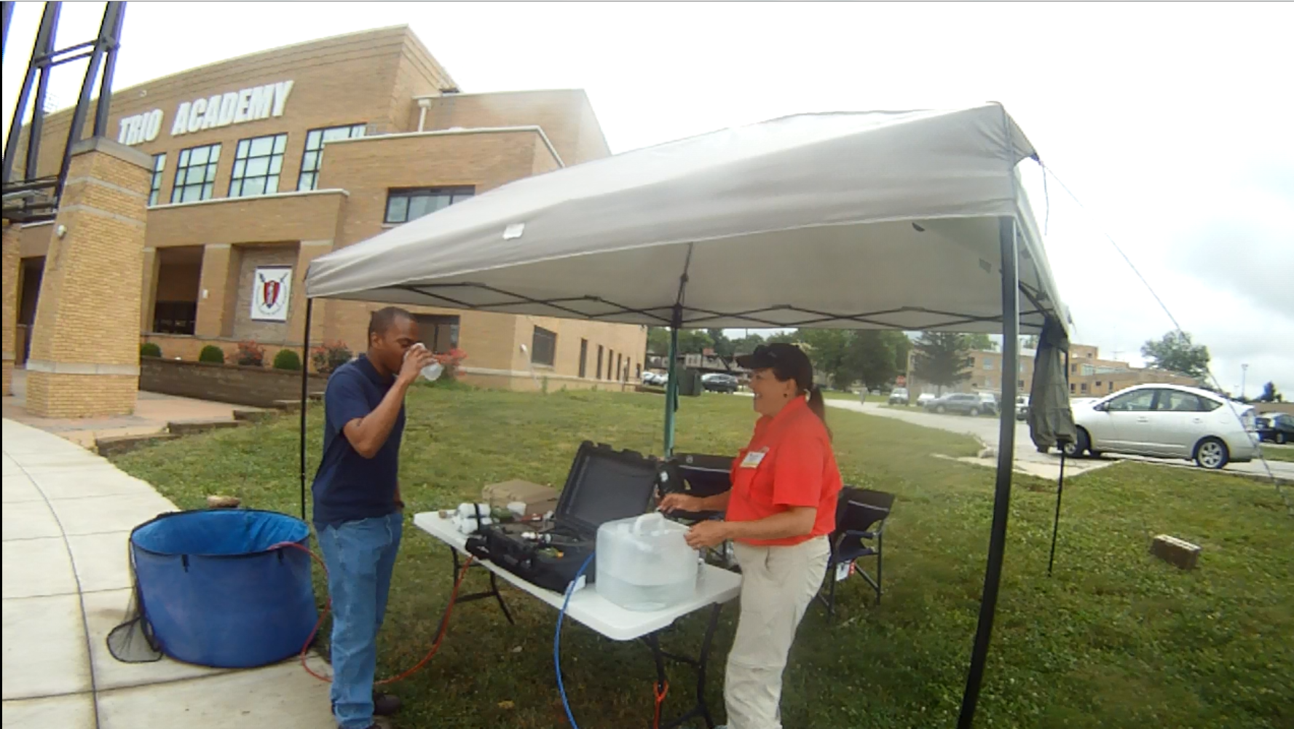t
The Roving Blue Demonstration tent.

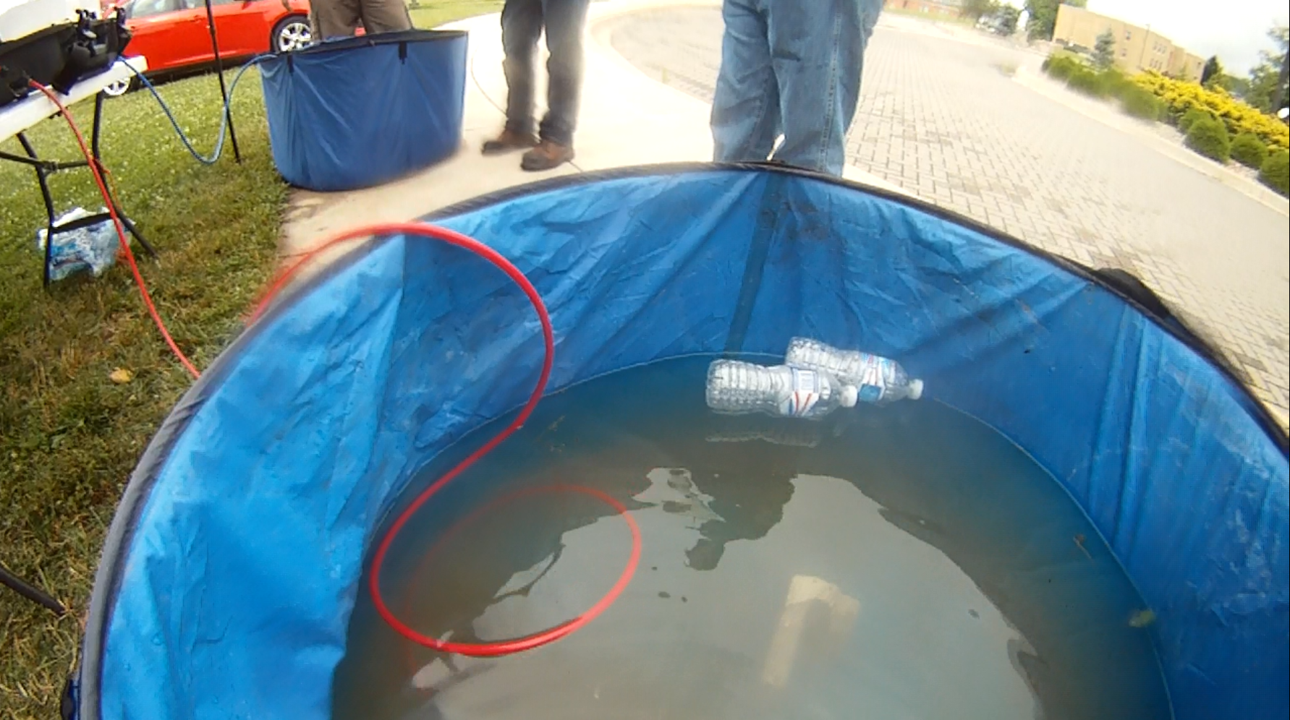
“Dirty Water Pool”

